**COMPUTER ARCHITECTURE EXPERIMENT– 3**

**Implementation of Synchronous Sequential Circuits**

**Aim:** In this experiment, students will be introduced to the concept of sequential circuits and implement a 2-bit Counter.

**Experimental Work:**

*Given the following sequential circuit:*

x

S

J

CP

K

R

Q

_

Q

B

S

J

CP

K

R

Q

_

Q

A

CP

1. Draw the logic diagram of the given sequential circuit in Circuit Maker 6.0.
   1. Implement your inputs as logic switches.

*Devices 🡪 Hotkeys2 🡪 logic switch*

* 1. Implement your circuit using logic gates and JK- Flip Flops (4027).

(You can search devices from *devices 🡪 search*)

* 1. Implement your outputs as logic displays.

*Devices 🡪 Hotkeys1 🡪 logic display*

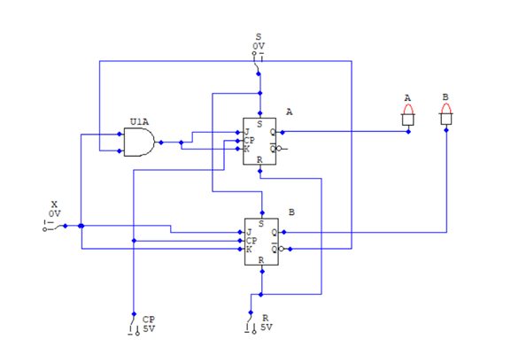

1. Run your circuit and complete the following state table:

|  |  |  |  |  |
| --- | --- | --- | --- | --- |
| **Present**  **State** | | | **Next**  **State** | |
| **A(t)** | **B(t)** | **x** | **A(t+1)** | **B(t+1)** |
| **0** | **0** | **0** | **0** | **0** |
| **0** | **0** | **1** | **1** | **1** |
| **0** | **1** | **0** | **0** | **1** |
| **0** | **1** | **1** | **0** | **0** |
| **1** | **0** | **0** | **1** | **0** |
| **1** | **0** | **1** | **0** | **1** |
| **1** | **1** | **0** | **1** | **1** |
| **1** | **1** | **1** | **1** | **0** |

1. Supply your flip-flop input equations:

**TA=AB’ TB=A**

**Next State Equations:**

**Q(t+1) = T.Q’+T’Q**

**A(t+1) = AB’A’+(AB’)’A**

**= AB’A’+(A’+B)A**

**= AB’A’+A’A+AB**

**= 0 +AB = AB**

**B(t+1) = TbQ’+ Tb‘Q**

**B(t+1) = AB’+ A‘B**

**B(t+1) = A⊕B**

**JA= B’x KA= B’x**

**JB=x KB=x**

**JA(t+1)= B’xA’ + (B’.x)’A => A’B’x + ABx’**

**JB(t+1) = B’x+Bx’**